Appendix. Variable definitions
Panel A. Variables in Tables 3–5
Variable
Definition
POWER
POWER = 1 – (RANK – MIN)/(MAX – MIN), where RANK is the rank of the
TMT member disclosed in the annual report of a firm-year with 1 being the
highest rank. MIN is the minimum of RANK (i.e., 1) and MAX is the maximum
of RANK (i.e., the number of TMT members in a firm-year). POWER ranges
from zero (lowest power) to one (highest power).
INV_RANK
The negative value of RANK.
CFO_POWER
CFO_INV_RANK
The normalized measure of power (i.e., POWER) of a CFO.
The negative value of CFO rank within each TMT.
Structural power
EXEC_DIR
COMP
A dummy variable indicating whether a TMT member is part of the firm’s board.
A TMT member’s total annual cash compensation (including bonuses) divided
by the total cash compensation of the highest paid manager.
NUM_TITLES
The number of top executive job titles held by a TMT member.
Ownership power
SHARE_OWN
FOUNDER
The stock ownership of a TMT member and her related parties acting in concert.
A dummy variable indicating whether a TMT member is disclosed in the IPO
prospectus as a top ten shareholder or a top management team member in the
IPO year.
CONTROLLER
A dummy variable indicating whether a TMT member is the ultimate controlling
shareholder of the firm.
Expert power
SKILL_MATCH
A dummy variable indicating whether there is a match between a TMT
member’s functional areas and her professional qualifications. For executives
with only generic job titles (i.e., Vice President) whose job functions are not
disclosed, SKILL_MATCH is coded as zero.
NUM_FUNCTIONS
NUM_POSITIONS
The number of functional areas in which a TMT member holds a post.
The number of senior executive positions a TMT member previously held based
on her resume.
Prestige power
NUM_DIR
The number of board seats a TMT member holds in other listed firms.
NUM_NONPROFIT The number of board seats a TMT member holds in non-for-profit organizations.
EDU
EDU is one if a TMT member’s educational level is technical secondary level
or below, two if the educational level is junior college level, three if the
educational level is a bachelor degree, four if the educational level is a master
degree, and five if the educational level is a doctor degree.
Political power
OFFICIAL
A dummy variable that equals one if a manager is a current or former
government official at the central, provincial or county government level, or a
representative of the People’s Congress or the Chinese People’s Political
Consultative Conference (CPPCC) at the national, provincial or county level.
PARENT_POS is three if a TMT member holds the position of both the
Chairman of the Board and the CEO at the parent company, two if the TMT
member holds the position of either the Chairman of the Board or the CEO but
not both at the parent company, one if the TMT member holds any managerial
PARENT_POS

Electronic copy available at: https://ssrn.com/abstract=3202028
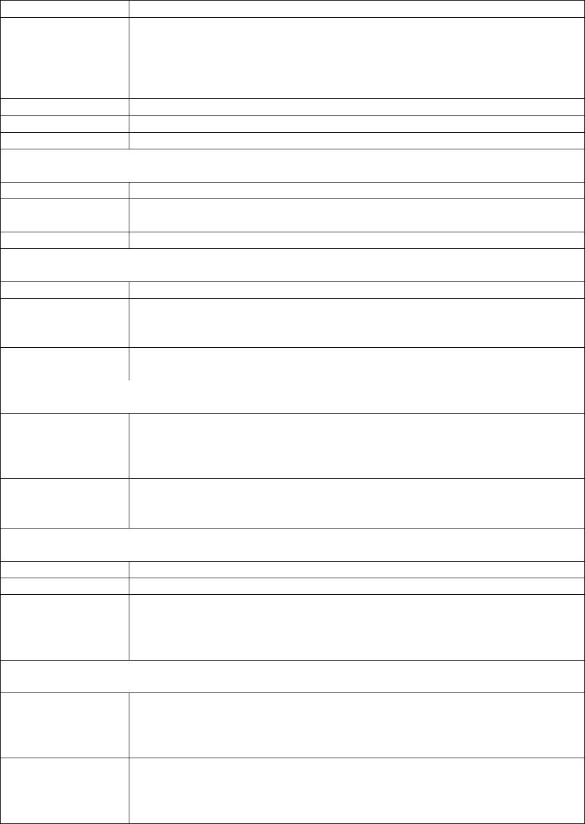

position lower than the Board Chairman and the CEO at the parent company,
and zero if the TMT member holds no managerial position at the parent
company.
Seniority power
AGE
The age of a TMT member.
TENURE
The number of years since a TMT member joined the firm.
Gender power
MALE
MALE equals one for male executives and zero for female executives.
Panel B. Additional variable in Table 6
Variable
Definition
COMP_POWER
COMP_POWER = 1 – (COMP_RANK – MIN)/(MAX – MIN), where COMP_RANK
is the rank of a TMT member based on total annual cash compensation (COMP)
with 1 being the highest rank. MIN is the minimum of COMP_RANK (i.e., 1) and
MAX is the maximum of COMP_RANK (i.e., the number of TMT members in a
firm-year). COMP_POWER ranges from zero (lowest power) to one (highest
power).
Panel C. Variables in Table 7
Variable
Definition
POWER-COMP_CORR
The correlation between POWER and COMP_POWER for all TMT
members (including the Board Chairman and the CEO) of firm i in year
t. We exclude firm-years with fewer than five TMT members.
A dummy variable that equals one if firm i is state-controlled, and zero
otherwise.
SOE
REG_INDUSTRY
A dummy variable that equals one if firm i is in a regulated industry,
and zero otherwise. The list of regulated industries is provided in Panel
E below.
SIZE
The natural logarithm of the book value of firm i’s total assets at the
end of year t-1.
LEVERAGE
GROWTH
Firm i’s book value of total liabilities divided by the book value of its
total assets at the end of year t-1.
Firm i’s market-to-book ratio at the end of year t-1, where the market
value of total assets is measured as the sum of the market value of
equity and the book value of total liabilities.
Panel D. Variables in Table 8
Variable
Definition
LOAN
The annual-average amount of bank loans borrowed by firm i over the
three-year period (year t to year t+2) divided by the book value of its
total assets at the end of year t-1. It is expressed in percentage points.
The annual-average amount of equity issued by firm i over the three-
year period (year t to year t+2) divided by the book value of its total
assets at the end of year t-1. It is expressed in percentage points.
The correlation between POWER and COMP_POWER for all TMT
members (including the Board Chairman and CEO) of firm i in year t-
1. We exclude firm-years with fewer than five TMT members.
The natural logarithm of the book value of firm i’s total assets at the
end of year t-1.
EQUITY
POWER-COMP_CORR
SIZE
LEVERAGE
Firm i’s book value of total liabilities divided by the book value of its
total assets at the end of year t-1.

Electronic copy available at: https://ssrn.com/abstract=3202028
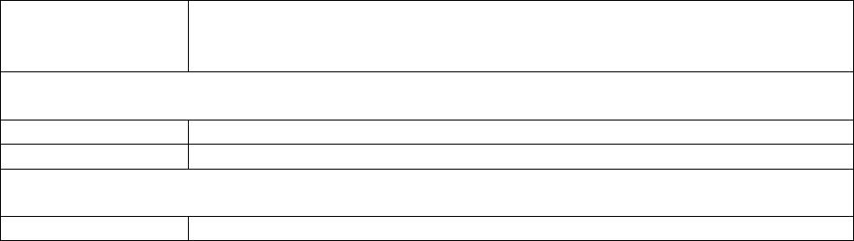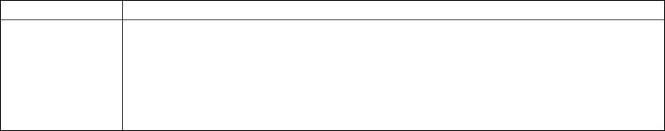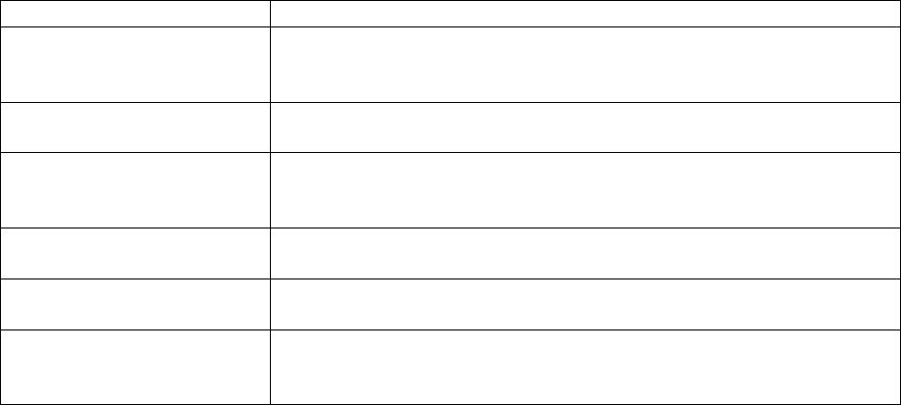

GROWTH
Firm i’s market-to-book ratio at the end of year t-1, where the market
value of total assets is measured as the sum of the market value of
equity and the book value of total liabilities.
Panel E. The list of regulated industries
Industry
Code
B
References
Wei et al. (2005), Fan et al. (2007),
Tian and Estrin (2008), Luo and Liu
(2009), Yu et al. (2010)
Mining
Manufacturing:
Petroleum processing, coking, and nuclear fuel
processing
C25
Luo and Liu (2009), Yu et al. (2010)
Ferrous metal smelting and rolling processing
Non-ferrous metal smelting and rolling processing
Automobile manufacturing
C31
C32
C36
Luo and Liu (2009)
Luo and Liu (2009)
Luo and Liu (2009)
Manufacturing of railways, ships, aircrafts,
spacecrafts and other transportation equipment
Electric power, heat, gas and water production and
supply
C37
D
Luo and Liu (2009)
Fan et al. (2007), Luo and Liu
(2009), Yu et al. (2010)
Construction:
Civil engineering construction
Transport, storage and postal service:
Railway transportation
Road transport
Waterway transport
Air transport
E48
Yu et al. (2010)
G53
G54
G55
G56
Luo and Liu (2009)
Luo and Liu (2009)
Luo and Liu (2009)
Luo and Liu (2009)
Information transmission, software and information
technology services:
Telecommunications, radio and television and
satellite transmission services
Internet and related services
Real estate
Culture, sports and entertainment
I63
Luo and Liu (2009)
I64
K
R
Luo and Liu (2009)
Fan et al. (2007), Yu et al. (2010)
Luo and Liu (2009)

Electronic copy available at: https://ssrn.com/abstract=3202028
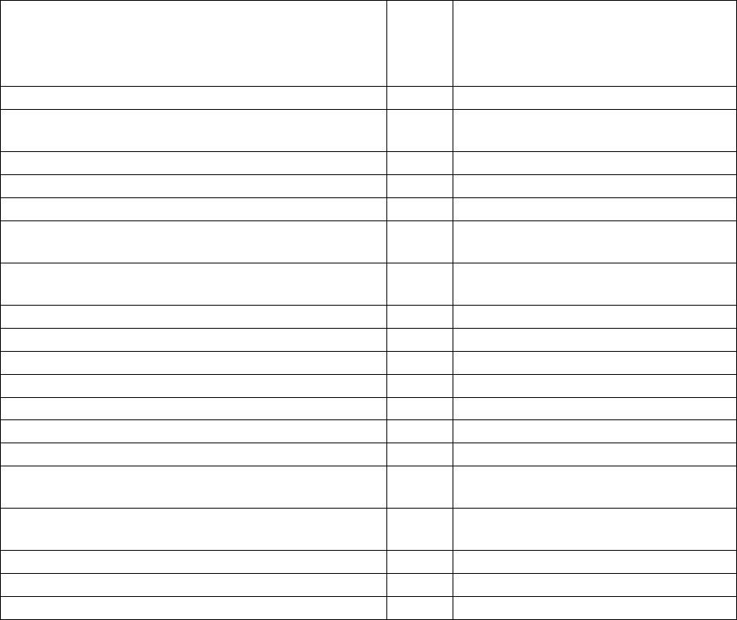

Table 1. Sample selection procedures
Full
sample
317,542
SOE
sample
168,568
Non-SOE
sample
133,222
All A-share firms over 2005 to 2013
Full sample: 17,122 firm-years, 2,554 unique firms
SOE sample: 8,425 firm-years, 1,209 unique firms
Non-SOE sample: 7,889 firm-years, 1,584 unique
firms
Eliminating individuals not belonging to
top management teams
(189,929)
(30,963)
(102,283)
(16,056)
(77,969)
(13,424)
Eliminating Board Chairmen and CEOs
Eliminating top management team members
that quit in the current year or take on
the position after the fiscal-year end
Eliminating observations with missing
compensation or age data
(5,722)
(492)
(2,509)
(344)
(2,950)
(139)
Eliminating top management teams
with only one member
(254)
(84)
(157)
Final sample
90,182
47,292
38,583
Full sample: 16,692 firm-years, 2,553 unique firms
SOE sample: 8,251 firm-years, 1,206 unique firms
Non-SOE sample: 7,656 firm-years, 1,578 unique
firms
Notes: This table shows the sample selection procedures. The number of individuals included or dropped
in each step is shown in the table. The number of individuals, firm-years or unique firms for the full
sample does not equal the summation of the numbers for the two subsamples because there are some
firm-years that are neither classified as state-controlled firms (SOEs) nor as non-state-controlled firms
(non-SOEs), and there are some firms that are classified as SOEs in some years but as non-SOEs in other
years.

Electronic copy available at: https://ssrn.com/abstract=3202028

Table 2. Sample distribution
Panel A. Distribution by year
Number of firms
Number of individuals
SOE
sample
Full
sample
1,297
1,342
1,489
1,564
1,699
2,073
2,301
2,441
2,486
16,692
SOE
sample
878
Non-SOE
sample
370
Full
sample
6,601
Non-SOE
sample
1,703
2,031
2,468
2,901
3,382
5,158
6,446
2005
2006
2007
2008
2009
2010
2011
2012
2013
Total
4,659
849
914
919
904
914
932
979
962
446
528
600
689
1,003
1,256
1,362
1,402
7,656
6,788
7,706
8,319
9,163
11,536
12,443
13,740
13,886
90,182
4,529
5,002
5,173
5,212
5,506
5,410
5,972
5,829
7,152
7,342
38,583
8,251
47,292
Panel B. Distribution by the size of top management team
Number of firms
Number of individuals
Full
sample
1,102
2,158
3,200
3,362
2,596
1,734
1,086
608
335
179
118
61
48
32
24
18
6
14
3
2
SOE
sample
356
858
1,419
1,653
1,436
1,032
632
355
212
106
73
40
25
23
9
9
1
7
0
Non-SOE
sample
705
1,205
1,619
1,571
1,028
612
389
226
109
66
41
19
20
8
13
9
4
6
Full
sample
2,204
6,474
12,800
16,810
15,576
12,138
8,688
5,472
3,350
1,969
1,416
793
672
480
384
306
108
266
60
42
SOE
sample
712
Non-SOE
sample
1,410
3,615
6,476
7,855
6,168
4,284
3,112
2,034
1,090
726
492
247
280
120
208
153
72
114
2
3
4
5
6
7
8
9
10
11
12
13
14
15
16
17
18
19
20
21
>=22
2,574
5,676
8,265
8,616
7,224
5,056
3,195
2,120
1,166
876
520
350
345
144
153
18
133
0
3
1
2
60
21
46
1
4
21
128
6
174
Total
16,692
8,251
7,656
90,182
47,292
38,583
Notes: Panel A shows the distribution of the sample firms by year for the full sample, state-controlled
firms (SOEs), and non-state-controlled firms (non-SOEs), respectively. Panel B shows the distribution of
the firm-years by the TMT size for the full sample, state-controlled firms (SOEs), and non-state-
controlled firms (non-SOEs), respectively.

Electronic copy available at: https://ssrn.com/abstract=3202028

Table 3. Summary statistics
Panel A. Full sample
N
Mean
SD
P25
Median
P75
Structural power
EXEC_DIR
COMP
90,182
90,182
90,182
0.23
0.60
1.38
0.42
0.25
0.59
0
0.43
1
0
0.63
1
0
0.79
2
NUM_TITLES
Ownership power
SHARE_OWN
FOUNDER
90,182
90,182
90,182
0.23
0.36
0.01
1.53
0.48
0.11
0
0
0
0
0
0
0.0004
1
0
CONTROLLER
Expert power
SKILL_MATCH
NUM_FUNCTIONS
NUM_POSITIONS
90,182
90,182
90,182
0.15
1.22
2.87
0.36
0.51
1.86
0
1
2
0
1
2
0
1
4
Prestige power
NUM_DIR
NUM_NONPROFIT
EDU
90,182
90,182
90,182
0.37
0.02
3.19
1.04
0.17
0.77
0
0
3
0
0
3
0
0
4
Political power
OFFICIAL
PARENT_POS
90,182
90,182
0.07
0.06
0.25
0.28
0
0
0
0
0
0
Seniority power
AGE
TENURE
90,182
90,182
45.26
4.51
6.90
3.14
40
2
45
4
50
6
Gender power
MALE
90,182
0.86
0.35
1
1
1

Electronic copy available at: https://ssrn.com/abstract=3202028

Panel B. SOE sample
N
Mean
SD
P25
Median
P75
Structural power
EXEC_DIR
COMP
47,292
47,292
47,292
0.18
0.63
1.31
0.38
0.25
0.56
0
0.5
1
0
0.69
1
0
0.8
2
NUM_TITLES
Ownership power
SHARE_OWN
FOUNDER
47,292
47,292
47,292
0.02
0.25
0
0.19
0.44
0
0
0
0
0
0
0
0
1
0
CONTROLLER
Expert power
SKILL_MATCH
NUM_FUNCTIONS
NUM_POSITIONS
47,292
47,292
47,292
0.18
1.23
2.95
0.38
0.52
1.94
0
1
2
0
1
2
0
1
4
Prestige power
NUM_DIR
NUM_NONPROFIT
EDU
47,292
47,292
47,292
0.38
0.02
3.23
1.06
0.17
0.73
0
0
3
0
0
3
0
0
4
Political power
OFFICIAL
PARENT_POS
47,292
47,292
0.08
0.05
0.27
0.26
0
0
0
0
0
0
Seniority power
AGE
TENURE
47,292
47,292
46.22
4.99
6.46
3.27
42
2
46
4
51
7
Gender power
MALE
47,292
0.88
0.33
1
1
1

Electronic copy available at: https://ssrn.com/abstract=3202028

Panel C. Non-SOE sample
N
Mean
SD
P25
Median
P75
Structural power
EXEC_DIR
COMP
38,583
38,583
38,583
0.30
0.55
1.46
0.46
0.24
0.62
0
0.38
1
0
0.56
1
1
0.73
2
NUM_TITLES
Ownership power
SHARE_OWN
FOUNDER
38,583
38,583
38,583
0.51
0.49
0.03
2.29
0.50
0.16
0
0
0
0
0
0
0.05
1
0
CONTROLLER
Expert power
SKILL_MATCH
NUM_FUNCTIONS
NUM_POSITIONS
38,583
38,583
38,583
0.11
1.22
2.73
0.32
0.49
1.71
0
1
2
0
1
2
0
1
4
Prestige power
NUM_DIR
NUM_NONPROFIT
EDU
38,583
38,583
38,583
0.36
0.02
3.12
1.01
0.17
0.80
0
0
3
0
0
3
0
0
4
Political power
OFFICIAL
PARENT_POS
38,583
38,583
0.05
0.08
0.23
0.30
0
0
0
0
0
0
Seniority power
AGE
TENURE
38,583
38,583
44.00
3.86
7.24
2.80
39
2
43
3
48
5
Gender power
MALE
38,583
0.83
0.38
1
1
1
Notes: This table reports the descriptive statistics for the 17 raw explanatory variables used in our
regression, for the full sample in Panel A, and for state-controlled firms (SOEs) and non-state-controlled
firms (non-SOEs) in Panels B and C, respectively. All variables are defined in the Appendix.

Electronic copy available at: https://ssrn.com/abstract=3202028

Table 4. Regression results on the construct validity of POWER
Panel A. Full sample
Dependent variable:
(1)
(2)
(3)
(4)
(5)
(6)
(7)
(8)
POWER
Structural
Ownership
Expert
Prestige
Political
Seniority
Gender
EXEC_DIR
COMP
0.518***
(0.007)
0.241***
(0.006)
0.458***
(0.007)
0.185***
(0.006)
NUM_TITLES
SHARE_OWN
FOUNDER
CONTROLLER
SKILL_MATCH
NUM_FUNCTIONS
NUM_POSITIONS
NUM_DIR
0.040***
(0.008)
0.039***
(0.008)
0.056***
(0.007)
0.017**
(0.008)
0.058***
(0.015)
-0.012*
(0.006)
-0.024***
(0.006)
0.061***
(0.005)
0.049***
(0.007)
0.237***
(0.011)
0.195***
(0.009)
0.301***
(0.020)
0.036***
(0.010)
-0.053***
(0.009)
0.151***
(0.007)
0.298***
(0.009)
NUM_NONPROFIT
EDU
0.166***
(0.022)
0.021**
(0.008)
0.058***
(0.016)
0.018***
(0.006)
OFFICIAL
0.097***
(0.012)
0.022**
(0.009)
PARENT_POS
AGE
0.380***
(0.012)
0.077***
(0.009)
0.116***
(0.006)
0.185***
(0.008)
TENURE
0.258***
(0.008)
0.095***
(0.007)
MALE
0.101***
(0.010)
0.052***
(0.006)
Firm×year FE
Observations
R-squared
Yes
90,182
0.446
Yes
90,182
0.098
Yes
90,182
0.029
Yes
90,182
0.054
Yes
90,182
0.043
Yes
90,182
0.131
Yes
90,182
0.008
Yes
90,182
0.495

Electronic copy available at: https://ssrn.com/abstract=3202028

Panel B. SOE sample
Dependent variable:
(1)
(2)
(3)
(4)
(5)
(6)
(7)
(8)
POWER
Structural
Ownership
Expert
Prestige
Political
Seniority
Gender
EXEC_DIR
COMP
0.510***
(0.010)
0.262***
(0.008)
0.042***
(0.011)
0.449***
(0.010)
0.206***
(0.008)
0.045***
(0.011)
0.018
(0.011)
0.019*
(0.011)
NUM_TITLES
SHARE_OWN
FOUNDER
CONTROLLER
SKILL_MATCH
NUM_FUNCTIONS
NUM_POSITIONS
NUM_DIR
0.142***
(0.016)
0.201***
(0.013)
0.038***
(0.013)
-0.067***
(0.012)
0.167***
(0.010)
0.001
(0.009)
-0.041***
(0.009)
0.068***
(0.008)
0.253***
(0.012)
0.050***
(0.010)
NUM_NONPROFIT
EDU
0.195***
(0.030)
0.030***
(0.012)
0.099***
(0.024)
0.030***
(0.008)
OFFICIAL
0.083***
(0.015)
0.027**
(0.012)
PARENT_POS
AGE
0.370***
(0.017)
0.115***
(0.014)
0.127***
(0.009)
0.189***
(0.012)
TENURE
0.226***
(0.011)
0.091***
(0.010)
MALE
0.130***
(0.014)
0.077***
(0.009)
Firm×year FE
Observations
R-squared
Yes
47,292
0.401
Yes
47,292
0.055
Yes
47,292
0.036
Yes
47,292
0.038
Yes
47,292
0.035
Yes
47,292
0.120
Yes
47,292
0.012
Yes
47,292
0.457

Electronic copy available at: https://ssrn.com/abstract=3202028

Panel C. Non-SOE sample
Dependent variable:
(1)
(2)
(3)
(4)
(5)
(6)
(7)
(8)
POWER
Structural
Ownership
Expert
Prestige
Political
Seniority
Gender
EXEC_DIR
COMP
0.528***
(0.009)
0.213***
(0.008)
0.039***
(0.011)
0.458***
(0.009)
0.159***
(0.008)
0.037***
(0.010)
0.099***
(0.009)
0.014
(0.010)
0.046***
(0.015)
-0.029***
(0.008)
-0.000
NUM_TITLES
SHARE_OWN
FOUNDER
CONTROLLER
SKILL_MATCH
NUM_FUNCTIONS
NUM_POSITIONS
NUM_DIR
0.333***
(0.013)
0.190***
(0.012)
0.244***
(0.022)
0.031**
(0.015)
-0.033***
(0.012)
0.128***
(0.011)
(0.008)
0.051***
(0.007)
0.047***
(0.009)
0.021
0.343***
(0.012)
0.138***
(0.032)
0.015
NUM_NONPROFIT
EDU
(0.019)
0.011
(0.012)
(0.008)
0.020
OFFICIAL
0.121***
(0.019)
0.383***
(0.017)
(0.013)
0.046***
(0.012)
0.106***
(0.008)
0.098***
(0.010)
0.029***
(0.008)
PARENT_POS
AGE
0.183***
(0.012)
0.299***
(0.011)
TENURE
MALE
0.071***
(0.013)
Firm×year FE
Observations
R-squared
Yes
38,583
0.501
Yes
38,583
0.160
Yes
38,583
0.020
Yes
38,583
0.075
Yes
38,583
0.052
Yes
38,583
0.147
Yes
38,583
0.004
Yes
38,583
0.548

Electronic copy available at: https://ssrn.com/abstract=3202028

Panel D. Raw variables
Dependent variable:
(1)
(2)
(3)
INV_RANK
Full sample
SOE sample
Non-SOE sample
Structural power
EXEC_DIR
2.467***
(0.052)
2.625***
(0.088)
2.276***
(0.051)
COMP
1.417***
(0.081)
1.483***
(0.111)
1.406***
(0.115)
NUM_TITLES
0.095***
(0.033)
0.122**
(0.052)
0.102***
(0.037)
Ownership power
SHARE_OWN
0.029***
(0.009)
0.338***
(0.054)
0.127
0.207***
(0.052)
0.263***
(0.079)
0.034***
(0.009)
0.424***
(0.071)
0.256
FOUNDER
CONTROLLER
(0.182)
(0.181)
Expert power
SKILL_MATCH
0.019
0.098
-0.092
(0.051)
-0.110***
(0.028)
0.103***
(0.010)
(0.071)
-0.157***
(0.038)
0.121***
(0.013)
(0.057)
-0.014
(0.033)
0.067***
(0.015)
NUM_FUNCTIONS
NUM_POSITIONS
Prestige power
NUM_DIR
0.098***
(0.017)
0.291***
(0.076)
0.061**
(0.029)
0.094***
(0.023)
0.431***
(0.115)
0.136**
(0.053)
0.100***
(0.019)
0.163*
(0.090)
0.020
NUM_NONPROFIT
EDU
(0.030)
Political power
OFFICIAL
0.152**
(0.061)
0.509***
(0.063)
0.167**
(0.082)
0.708***
(0.092)
0.119
(0.093)
0.317***
(0.086)
PARENT_POS
Seniority power
AGE
0.033***
(0.003)
0.044***
(0.004)
0.026***
(0.003)
TENURE
0.108***
(0.012)
0.102***
(0.015)
0.112***
(0.017)
Gender power
MALE
0.210***
(0.039)
0.347***
(0.060)
0.079
(0.049)
Firm×year FE
Observations
R-squared
Yes
90,182
0.601
Yes
47,292
0.583
Yes
38,583
0.634

Electronic copy available at: https://ssrn.com/abstract=3202028

Notes: Panel A shows the OLS regression results of POWER for the full sample. Panels B and C show
the regression results of POWER for state-controlled firms (SOEs) and non-state-controlled firms (non-
SOEs), respectively. Panel D shows the OLS regression results of INV_RANK for the full sample and the
two subsamples. Because POWER is expressed in normalized ranking, we also normalize the 17
explanatory variables in the regression model in Panels A, B and C. We show the regression results using
raw values for the dependent variable and explanatory variables in Panel D. CONTROLLER is dropped
from the regressions for the SOE sample because it is always zero for SOEs. All variables are defined in
the Appendix. All regressions include firm×year fixed effects. Heteroskedasticity-consistent standard
errors clustered at the firm level are shown in parentheses below the coefficients. ***, **, and * denote
significance at the 1%, 5%, and 10% levels for two-tailed tests, respectively.

Electronic copy available at: https://ssrn.com/abstract=3202028

Table 5. CFO power
Panel A. Distribution of CFOs by their rank
Number of CFOs
SOE sample
CFO rank
Full sample
Non-SOE sample
N
3,103
2,972
2,754
2,389
1,821
1,138
608
%
20
19
18
16
12
7
N
1,491
1,320
1,231
1,127
955
%
20
18
17
15
13
8
N
1,471
1,537
1,376
1,164
784
%
20
21
19
16
11
7
1
2
3
4
5
6
591
478
7
4
356
5
227
3
>= 8
621
4
337
5
250
3
Total
15,406
100
7,408
100
7,287
100

Electronic copy available at: https://ssrn.com/abstract=3202028

Panel B. Validation of CFO power using CFO_POWER
Dependent variable:
(1)
(2)
(3)
CFO_POWER
Full sample
SOE sample
Non-SOE sample
Structural power
EXEC_DIR
0.385***
(0.012)
0.390***
(0.017)
0.378***
(0.017)
COMP
0.126***
(0.009)
0.113***
(0.012)
0.134***
(0.012)
NUM_TITLES
0.128***
(0.012)
0.141***
(0.017)
0.113***
(0.016)
Ownership power
SHARE_OWN
0.007
-0.034*
(0.019)
0.004
0.050***
(0.016)
-0.034**
(0.014)
-0.039
(0.012)
-0.023**
(0.011)
-0.038
FOUNDER
(0.017)
CONTROLLER
(0.039)
(0.039)
Expert power
SKILL_MATCH
-0.025**
(0.010)
-0.001
(0.014)
0.081***
(0.010)
-0.015
(0.014)
-0.001
(0.019)
0.096***
(0.014)
-0.052***
(0.015)
-0.008
(0.018)
0.063***
(0.013)
NUM_FUNCTIONS
NUM_POSITIONS
Prestige power
NUM_DIR
0.015
0.012
0.017
(0.011)
0.042
(0.038)
0.008
(0.016)
0.045
(0.056)
0.019
(0.015)
0.048
(0.047)
0.007
NUM_NONPROFIT
EDU
(0.009)
(0.013)
(0.012)
Political power
OFFICIAL
-0.006
-0.018
(0.021)
0.018
-0.001
(0.026)
0.035*
(0.021)
(0.016)
0.032**
(0.016)
PARENT_POS
(0.026)
Seniority power
AGE
0.109***
(0.011)
0.110***
(0.017)
0.127***
(0.014)
TENURE
0.091***
(0.010)
0.066***
(0.015)
0.101***
(0.015)
Gender power
MALE
0.015*
(0.008)
0.032***
(0.012)
0.005
(0.011)
Industry×year FE
Observations
R-squared
Yes
15,406
0.481
Yes
7,408
0.473
Yes
7,287
0.499

Electronic copy available at: https://ssrn.com/abstract=3202028

Panel C. Validation of CFO rank using raw variables
Dependent variable:
(1)
(2)
(3)
CFO_INV_RANK
Full sample
SOE sample
Non-SOE sample
Structural power
EXEC_DIR
1.841***
(0.071)
0.330***
(0.109)
0.370***
(0.047)
1.864***
(0.110)
0.237
(0.153)
0.459***
(0.073)
1.738***
(0.095)
0.596***
(0.149)
0.306***
(0.062)
COMP
NUM_TITLES
Ownership power
SHARE_OWN
0.059***
(0.012)
-0.139**
(0.061)
-0.320
0.203
0.054***
(0.010)
-0.266***
(0.080)
-0.353*
(0.212)
(0.217)
-0.153
(0.107)
FOUNDER
CONTROLLER
(0.206)
Expert power
SKILL_MATCH
-0.298***
(0.075)
0.061
(0.062)
0.044***
(0.015)
-0.181*
(0.108)
0.148
(0.092)
0.074***
(0.021)
-0.379***
(0.107)
-0.010
(0.082)
0.018
NUM_FUNCTIONS
NUM_POSITIONS
(0.021)
Prestige power
NUM_DIR
-0.055**
(0.025)
0.188
(0.147)
-0.044
-0.094***
(0.036)
0.182
(0.221)
-0.068
0.011
(0.023)
0.173
(0.192)
0.025
NUM_NONPROFIT
EDU
(0.035)
(0.057)
(0.042)
Political power
OFFICIAL
-0.136
-0.181
(0.149)
0.160
-0.109
(0.163)
0.144
(0.109)
0.212***
(0.080)
PARENT_POS
(0.138)
(0.093)
Seniority power
AGE
0.016***
(0.004)
0.025***
(0.007)
0.021***
(0.005)
TENURE
0.049***
(0.009)
0.047***
(0.013)
0.060***
(0.015)
Gender power
MALE
-0.026
0.051
-0.106
(0.060)
(0.095)
(0.074)
Industry×year FE
Observations
R-squared
Yes
15,406
0.302
Yes
7,408
0.310
Yes
7,287
0.330
Notes: Panel A shows the distribution of CFOs by their rank within each TMT (after excluding the Board
Chairman and CEO) for the full sample, state-controlled firms (SOEs), and non-state-controlled firms
(non-SOEs), respectively. Panel B shows the OLS regression results of CFO_POWER for the full sample

Electronic copy available at: https://ssrn.com/abstract=3202028

and the two subsamples. Because CFO_POWER is expressed in normalized ranking, we also normalize
the 17 explanatory variables in the regression model. Panel C shows the OLS regression results of
CFO_INV_RANK for the full sample and the two subsamples, using raw values for the dependent variable
and explanatory variables. CONTROLLER is dropped from the regressions for the SOE sample because
it is always zero for SOEs. All variables are defined in the Appendix. All regressions include industry-
year fixed effects. Heteroskedasticity-consistent standard errors clustered at the firm level are shown in
parentheses below the coefficients. ***, **, and * denote significance at the 1%, 5%, and 10% levels for
two-tailed tests, respectively.

Electronic copy available at: https://ssrn.com/abstract=3202028

Table 6. Replication using alternative power proxies based on annual cash compensation
(1)
(2)
(3)
Dependent variable:
POWER
COMP
COMP_POWER
Structural power
EXEC_DIR
0.480***
(0.007)
0.123***
(0.010)
0.142***
(0.009)
NUM_TITLES
0.044***
(0.008)
0.026***
(0.008)
0.017**
(0.008)
Ownership power
SHARE_OWN
0.072***
(0.008)
0.015*
0.084***
(0.010)
-0.013
0.083***
(0.010)
-0.012
FOUNDER
(0.008)
0.060***
(0.015)
(0.010)
0.012
(0.033)
(0.009)
-0.006
(0.031)
CONTROLLER
Expert power
SKILL_MATCH
-0.005
0.039***
(0.008)
-0.029***
(0.007)
0.088***
(0.007)
0.040***
(0.008)
-0.033***
(0.007)
0.087***
(0.006)
(0.007)
-0.030***
(0.006)
0.077***
(0.005)
NUM_FUNCTIONS
NUM_POSITIONS
Prestige power
NUM_DIR
0.060***
(0.007)
0.055***
(0.016)
0.024***
(0.006)
0.059***
(0.009)
-0.017
(0.021)
0.029***
(0.007)
0.064***
(0.009)
-0.012
(0.020)
0.030***
(0.007)
NUM_NONPROFIT
EDU
Political power
OFFICIAL
0.016*
-0.035***
(0.011)
-0.095***
(0.016)
-0.034***
(0.011)
-0.076***
(0.015)
(0.009)
0.060***
(0.010)
PARENT_POS
Seniority power
AGE
0.136***
(0.007)
0.113***
(0.008)
0.117***
(0.007)
TENURE
0.124***
(0.007)
0.157***
(0.008)
0.157***
(0.008)
Gender power
MALE
0.066***
(0.007)
0.076***
(0.008)
0.071***
(0.008)
Firm×year FE
Observations
R-squared
Yes
90,182
0.463
Yes
90,182
0.328
Yes
90,182
0.253
Notes: This table shows the replication of the model in panel A of Table 4 using COMP and
COMP_POWER as dependent variables. To facilitate comparison, we reproduce the regression results in
panel A of Table 4 (excluding COMP as an explanatory variable) in the first column. All variables are
defined in the Appendix. All regressions include firm×year fixed effects. Heteroskedasticity-consistent

Electronic copy available at: https://ssrn.com/abstract=3202028

standard errors clustered at the firm level are shown in parentheses below the coefficients. ***, **, and
* denote significance at the 1%, 5%, and 10% levels for two-tailed tests, respectively.

Electronic copy available at: https://ssrn.com/abstract=3202028

Table 7. Determinants of the power-compensation correlation
Panel A. Descriptive statistics
N
Mean
SD
P25
Median
P75
POWER-COMP_CORR
SOE
14,334
14,334
14,334
12,878
12,878
12,878
0.39
0.54
0.32
21.65
0.48
1.72
0.45
0.50
0.46
1.28
0.22
1.08
0.04
0
0.44
1
0.81
1
REG_INDUSTRY
SIZE
0
0
1
20.78
0.31
1.12
21.47
0.49
1.37
22.28
0.63
1.88
LEVERAGE
GROWTH
Panel B. OLS regression results
Dependent variable:
(1)
(2)
(3)
POWER-COMP_CORR
SOE
-0.182***
(0.014)
-0.179***
(0.016)
-0.181***
(0.017)
REG_INDUSTRY
SIZE
-0.073***
(0.016)
-0.080***
(0.017)
0.005
0.001
(0.006)
-0.070**
(0.034)
-0.024***
(0.006)
0.472***
(0.136)
(0.008)
-0.075**
(0.036)
-0.021***
(0.007)
0.529***
(0.163)
LEVERAGE
GROWTH
Constant
0.515***
(0.010)
Industry×year FE
Observations
R-squared
No
14,334
0.053
No
12,878
0.054
Yes
12,878
0.071
Notes: Panel A shows the descriptive statistics for the regression variables. Panel B shows the regression
results of the determinant model without and with industry×year fixed effects. All variables are defined
in the Appendix. SIZE, LEVERAGE, and GROWTH are winsorized at the top and bottom one percent.
Heteroskedasticity-consistent standard errors clustered at the firm level are shown in parentheses below
the coefficients. ***, **, and * denote significance at the 1%, 5%, and 10% levels for two-tailed tests,
respectively.

Electronic copy available at: https://ssrn.com/abstract=3202028

Table 8. The relation between the power-compensation correlation and corporate financing
Panel A. Descriptive statistics
N
Mean
SD
P25
Median
P75
LOAN
14,944
14,944
14,944
14,459
14,459
14,459
27.06
9.28
0.39
21.77
0.48
1.78
29.74
29.10
0.45
1.33
0.22
1.12
6.58
0.00
0.04
20.84
0.30
1.14
20.84
0.00
0.44
21.57
0.48
1.42
37.25
6.45
0.81
22.42
0.64
1.97
EQUITY
POWER-COMP_CORR
SIZE
LEVERAGE
GROWTH
Panel B. OLS regression results for debt financing
Dependent variable:
(1)
(2)
(3)
LOAN
POWER-COMP_CORR
SIZE
-5.260***
(0.942)
-2.983***
(0.827)
-2.728***
(0.386)
-1.991**
(0.782)
-2.110***
(0.391)
LEVERAGE
GROWTH
48.814***
(2.125)
0.246
46.304***
(2.208)
1.020*
(0.527)
(0.604)
Constant
29.129***
(0.687)
63.623***
(8.313)
49.590***
(8.461)
Industry×year FE
Observations
R-squared
No
14,944
0.006
No
14,459
0.131
Yes
14,459
0.203
Panel C. OLS regression results for equity financing
Dependent variable:
(1)
(2)
(3)
EQUITY
POWER-COMP_CORR
SIZE
-2.672***
(0.780)
-2.007***
(0.694)
-3.208***
(0.281)
-1.876***
(0.683)
-4.168***
(0.365)
LEVERAGE
GROWTH
7.659***
(2.074)
4.862***
(0.657)
10.306***
(2.211)
5.202***
(0.745)
Constant
10.330***
(0.513)
66.967***
(5.909)
85.933***
(7.876)
Industry×year FE
Observations
R-squared
No
14,944
0.002
No
14,459
0.082
Yes
14,459
0.146

Electronic copy available at: https://ssrn.com/abstract=3202028

Notes: Panel A shows the descriptive statistics for the regression variables. Panel B shows the regression
results of the debt financing model without and with industry×year fixed effects. Panel C shows the
regression results of the equity financing model without and with industry×year fixed effects. All
variables are defined in the Appendix. LOAN, EQUITY, SIZE, LEVERAGE, and GROWTH are winsorized
at the top and bottom one percent. Heteroskedasticity-consistent standard errors clustered at the firm level
are shown in parentheses below the coefficients. ***, **, and * denote significance at the 1%, 5%, and
10% levels for two-tailed tests, respectively.

Electronic copy available at: https://ssrn.com/abstract=3202028

Online Appendix
for
“Top Management Team Power in China: Measurement and Validation”
Bin Ke , Xinshu Mao , Bin Wang , Luo Zuo
1 2 3 4
1
Department of Accounting, Business School, National University of Singapore, Mochtar Riady Building, BIZ
1, # 07-53, 15 Kent Ridge Drive, Singapore 119245. Tel: +65 66013133. Fax: +65 67736493. Email:
bizk@nus.edu.sg.
2
Department of Accounting, Business School, Beijing Technology and Business University, 511 Complex
Building, 33 Fucheng Road, China P.R. 100048. Tel: +86 1068984593. Fax: +86 1068984593. Email:
maoxinshu@163.com.
3
Department of Finance, Business School, Beijing Technology and Business University, 612 Complex Building,
33 Fucheng Road, China P.R. 100048. Tel: +86 1068988713. Fax: +86 1068988713. Email: bwing65@sina.com.
4
Samuel Curtis Johnson Graduate School of Management, Cornell University, 349 Sage Hall, Ithaca, NY 14853,
USA. Tel: +1 6072554002. Fax: +1 6072544590. Email: luozuo@cornell.edu.
Electronic copy available at: https://ssrn.com/abstract=3202028

Table A1. Board TMT members versus non-board TMT members
Panel A. Board TMT members
Dependent variable:
(1)
(2)
(3)
POWER
Full sample
SOE sample
Non-SOE sample
Structural power
COMP
0.226***
(0.019)
0.230***
(0.030)
0.221***
(0.024)
NUM_TITLES
-0.138***
(0.029)
-0.151***
(0.048)
-0.114***
(0.035)
Ownership power
SHARE_OWN
0.256***
(0.029)
-0.029
0.107**
(0.050)
0.017
0.338***
(0.033)
-0.065
FOUNDER
(0.040)
0.335***
(0.052)
(0.056)
(0.054)
0.314***
(0.055)
CONTROLLER
Expert power
SKILL_MATCH
-0.067*
(0.035)
-0.056*
(0.031)
0.118***
(0.021)
-0.055
(0.062)
-0.070
(0.053)
0.139***
(0.036)
-0.085**
(0.042)
-0.054
(0.037)
0.097***
(0.025)
NUM_FUNCTIONS
NUM_POSITIONS
Prestige power
NUM_DIR
0.141***
(0.027)
0.018
(0.063)
0.032
0.149***
(0.047)
0.142
(0.126)
0.060
0.122***
(0.033)
-0.019
(0.067)
0.024
NUM_NONPROFIT
EDU
(0.023)
(0.042)
(0.028)
Political power
OFFICIAL
0.054
0.017
0.075
(0.043)
0.283***
(0.038)
(0.068)
0.382***
(0.059)
(0.052)
0.206***
(0.049)
PARENT_POS
Seniority power
AGE
0.152***
(0.021)
0.171***
(0.037)
0.146***
(0.026)
TENURE
0.124***
(0.032)
0.100**
(0.048)
0.172***
(0.041)
Gender power
MALE
0.036
(0.032)
-0.035
(0.064)
0.075**
(0.035)
Firm×year FE
Observations
R-squared
Yes
15,435
0.271
Yes
5,699
0.227
Yes
9,086
0.321

Electronic copy available at: https://ssrn.com/abstract=3202028

Panel B. Non-board TMT members
Dependent variable:
(1)
(2)
(3)
POWER
Full sample
SOE sample
Non-SOE sample
Structural power
COMP
0.266***
(0.008)
0.281***
(0.011)
0.245***
(0.013)
NUM_TITLES
0.078***
(0.011)
0.070***
(0.015)
0.098***
(0.017)
Ownership power
SHARE_OWN
0.086***
(0.012)
0.043***
(0.012)
0.086
0.041**
(0.017)
0.037**
(0.016)
0.143***
(0.018)
0.042**
(0.018)
0.058
FOUNDER
CONTROLLER
(0.061)
(0.062)
Expert power
SKILL_MATCH
-0.015
0.002
-0.046***
(0.017)
0.003
(0.014)
0.066***
(0.012)
(0.011)
-0.032***
(0.009)
0.075***
(0.008)
(0.014)
-0.051***
(0.012)
0.078***
(0.011)
NUM_FUNCTIONS
NUM_POSITIONS
Prestige power
NUM_DIR
0.085***
(0.012)
0.089***
(0.029)
0.029***
(0.009)
0.081***
(0.015)
0.134***
(0.037)
0.041***
(0.012)
0.090***
(0.019)
0.024
(0.044)
0.018
NUM_NONPROFIT
EDU
(0.014)
Political power
OFFICIAL
0.040***
(0.015)
0.118***
(0.022)
0.040**
(0.018)
0.165***
(0.028)
0.047*
(0.027)
0.064*
(0.034)
PARENT_POS
Seniority power
AGE
0.150***
(0.009)
0.155***
(0.012)
0.152***
(0.014)
TENURE
0.130***
(0.010)
0.122***
(0.013)
0.143***
(0.016)
Gender power
MALE
0.084***
(0.010)
0.111***
(0.013)
0.052***
(0.016)
Firm×year FE
Observations
R-squared
Yes
68,132
0.225
Yes
38,526
0.239
Yes
26,252
0.216
Notes: This table shows the regression results of POWER for TMT members who are board members
(Panel A) versus TMT members who are not (Panel B) separately. Because POWER is expressed in
normalized ranking, we also normalize the 16 explanatory variables in the regression model. EXEC_DIR
is dropped from the regressions because it is always one for director executives (Panel A) and zero for
non-director executives (Panel B). CONTROLLER is dropped from the regressions for the SOE sample

Electronic copy available at: https://ssrn.com/abstract=3202028

because it is always zero for SOEs. All variables are defined in the Appendix. All regressions include
firm×year fixed effects. Heteroskedasticity-consistent standard errors clustered at the firm level are
shown in parentheses below the coefficients. ***, **, and * denote significance at the 1%, 5%, and 10%
levels for two-tailed tests, respectively.

Electronic copy available at: https://ssrn.com/abstract=3202028

Table A2. Deleting firms with smaller TMT size
Dependent variable:
(1)
(2)
(3)
POWER
Full sample
SOE sample
Non-SOE sample
Structural power
EXEC_DIR
0.439***
(0.007)
0.434***
(0.010)
0.436***
(0.009)
COMP
0.180***
(0.006)
0.196***
(0.009)
0.156***
(0.008)
NUM_TITLES
0.035***
(0.008)
0.041***
(0.012)
0.033***
(0.010)
Ownership power
SHARE_OWN
0.054***
(0.007)
0.015**
(0.008)
0.032**
(0.014)
0.024**
(0.011)
0.014
0.094***
(0.009)
0.017
(0.010)
0.026*
(0.014)
FOUNDER
(0.011)
CONTROLLER
Expert power
SKILL_MATCH
-0.008
0.004
-0.025***
(0.008)
-0.005
(0.007)
0.045***
(0.007)
(0.006)
-0.026***
(0.006)
0.060***
(0.005)
(0.009)
-0.036***
(0.009)
0.070***
(0.008)
NUM_FUNCTIONS
NUM_POSITIONS
Prestige power
NUM_DIR
0.053***
(0.007)
0.065***
(0.016)
0.014**
(0.006)
0.055***
(0.009)
0.101***
(0.023)
0.024***
(0.008)
0.048***
(0.009)
0.025
(0.020)
0.007
NUM_NONPROFIT
EDU
(0.008)
Political power
OFFICIAL
0.029***
(0.009)
0.030***
(0.012)
0.031**
(0.013)
PARENT_POS
0.077***
(0.010)
0.112***
(0.015)
0.042***
(0.012)
Seniority power
AGE
0.108***
(0.007)
0.127***
(0.009)
0.088***
(0.009)
TENURE
0.109***
(0.008)
0.104***
(0.011)
0.114***
(0.011)
Gender power
MALE
0.048***
(0.007)
0.069***
(0.010)
0.026***
(0.008)
Firm×year FE
Observations
R-squared
Yes
68,704
0.502
Yes
38,330
0.466
Yes
27,082
0.562
Notes: We exclude firm-years with fewer than five TMT members. Because POWER is expressed in
normalized ranking, we also normalize the 17 explanatory variables in the regression model.
CONTROLLER is dropped from the regressions for the SOE sample because it is always zero for SOEs.

Electronic copy available at: https://ssrn.com/abstract=3202028

All variables are defined in the Appendix. All regressions include firm×year fixed effects.
Heteroskedasticity-consistent standard errors clustered at the firm level are shown in parentheses below
the coefficients. ***, **, and * denote significance at the 1%, 5%, and 10% levels for two-tailed tests,
respectively.

Electronic copy available at: https://ssrn.com/abstract=3202028

Table A3. TMT members including the Board Chairman and CEO
Dependent variable:
(1)
(2)
(3)
POWER
Full sample
SOE sample
Non-SOE sample
Structural power
EXEC_DIR
0.472***
(0.004)
0.470***
(0.005)
0.452***
(0.005)
COMP
0.107***
(0.004)
0.101***
(0.005)
0.121***
(0.005)
NUM_TITLES
-0.072***
(0.004)
-0.061***
(0.006)
-0.069***
(0.005)
Ownership power
SHARE_OWN
0.022***
(0.005)
0.013***
(0.005)
0.002
(0.006)
0.008
0.046***
(0.006)
0.017***
(0.006)
FOUNDER
(0.006)
CONTROLLER
0.078***
(0.005)
0.091***
(0.006)
Expert power
SKILL_MATCH
-0.003
0.008
-0.016***
(0.005)
-0.008
(0.005)
0.073***
(0.005)
(0.004)
-0.021***
(0.004)
0.086***
(0.003)
(0.006)
-0.029***
(0.005)
0.089***
(0.005)
NUM_FUNCTIONS
NUM_POSITIONS
Prestige power
NUM_DIR
0.040***
(0.004)
0.033***
(0.005)
0.052***
(0.006)
NUM_NONPROFIT
EDU
0.039***
(0.006)
0.023***
(0.003)
0.045***
(0.009)
0.029***
(0.005)
0.030***
(0.009)
0.017***
(0.005)
Political power
OFFICIAL
0.025***
(0.004)
0.027***
(0.005)
0.020***
(0.006)
PARENT_POS
0.105***
(0.005)
0.130***
(0.006)
0.070***
(0.007)
Seniority power
AGE
0.091***
(0.004)
0.100***
(0.006)
0.082***
(0.006)
TENURE
0.067***
(0.005)
0.065***
(0.006)
0.072***
(0.007)
Gender power
MALE
0.042***
(0.004)
0.061***
(0.006)
0.025***
(0.005)
Firm×year FE
Observations
R-squared
Yes
120,385
0.706
Yes
62,850
0.693
Yes
51,781
0.727
Notes: We repeat the analysis after including the Board Chairman and CEO in the sample. Because
POWER is expressed in normalized ranking, we also normalize the 17 explanatory variables in the
regression model. CONTROLLER is dropped from the regressions for the SOE sample because it is

Electronic copy available at: https://ssrn.com/abstract=3202028

always zero for SOEs. All variables are defined in the Appendix. All regressions include firm×year fixed
effects. Heteroskedasticity-consistent standard errors clustered at the firm level are shown in parentheses
below the coefficients. ***, **, and * denote significance at the 1%, 5%, and 10% levels for two-tailed
tests, respectively.

Electronic copy available at: https://ssrn.com/abstract=3202028

Table A4. The relation between CFO power and long-lived asset impairment
Panel A. Descriptive statistics
N
Mean
SD
P25
Median
P75
WO
13,550
13,550
13,550
13,550
13,550
13,550
13,550
13,550
0.12
0.28
0.28
0.19
0.10
0.17
0.21
0.07
0.66
0.45
0.45
0.39
0.30
0.38
0.41
0.25
0
0
0
0
0
0
0
0
0
0
0
0
0
0
0
0
0
1
1
0
0
0
0
0
ACCOUNTING
POWER_ONLY
ACCOUNTING_ONLY_1
POWER_ACCOUNTING
COMP_ONLY
ACCOUNTING_ONLY_2
COMP_ACCOUNTING
Economic factors
DSALES
DE
13,550
13,550
13,550
0.22
0.01
0.01
0.62
0.09
0.11
-0.01
-0.01
-0.04
0.13
0
0.30
0.02
0.05
DOCF
0
Reporting incentives
DMGT
13,550
13,550
13,550
13,550
13,550
13,550
13,550
13,550
0.27
0.20
0.70
0.73
0.02
0.54
0.36
0.19
0.45
0.40
0.46
0.45
0.14
0.50
0.05
0.40
0
0
1
BATH
0
0
0
SMOOTH
DEBT
0
0
1
1
1
1
ST
0
0
0
BIGAC
0
1
1
BOARD_IND
CEO_CHAIR
0.33
0
0.33
0
0.38
0
Board Chairman characteristics
CHAIR_AGE
13,550
13,550
13,550
13,550
13,550
13,550
13,550
13,550
13,550
50.98
5.83
0.04
3.34
0.36
1.03
0.96
0.06
8.83
6.92
3.43
0.11
0.76
0.48
0.95
0.20
0.24
5.91
46
3
51
56
CHAIR_TENURE
CHAIR_SHARE_OWN
CHAIR_EDU
5
8
0
0
0
3
3
0
4
CHAIR_OFFICIAL
CHAIR_PARENT_POS
CHAIR_MALE
0
1
0
1
2
1
1
1
CHAIR_ACCOUNTING
CHAIR_COMP
0
0
0
0
12.3
13.12
CEO characteristics
CEO_AGE
13,550
13,550
13,550
13,550
47.37
5.62
0.03
3.35
6.24
3.34
0.08
0.72
43
3
47
5
51
8
CEO_TENURE
CEO_SHARE_OWN
CEO_EDU
0
0
0
3
3
4

Electronic copy available at: https://ssrn.com/abstract=3202028

CEO_OFFICIAL
CEO_PARENT_POS
CEO_MALE
13,550
13,550
13,550
13,550
13,550
0.17
0.30
0.94
0.10
12.4
0.37
0.57
0.23
0.30
2.26
0
0
0
0
1
0
1
0
1
CEO_ACCOUNTING
CEO_COMP
0
0
0
12.19
12.79
13.31
CFO characteristics
CFO_AGE
13,550
13,550
13,550
13,550
13,550
13,550
13,550
13,550
44
4.72
0
6.51
3.10
0
39
43
48
CFO_TENURE
CFO_SHARE_OWN
CFO_EDU
2
4
7
0
0
0
3.13
0.06
0.05
0.73
12.15
0.71
0.23
0.22
0.44
1.65
3
3
4
CFO_OFFICIAL
CFO_PARENT_POS
CFO_MALE
0
0
0
0
0
0
0
1
1
CFO_COMP
11.76
12.36
12.89
Electronic copy available at: https://ssrn.com/abstract=3202028

Panel B. OLS regression results
Partitioning variable
(2)
Dependent variable:
(1)
(3)
WO
Baseline
HIGH_POWER
HIGH_COMP
ACCOUNTING
-0.020*
(0.012)
ACCOUNTING_ONLY_1
POWER_ACCOUNTING
POWER_ONLY
-0.004
(0.016)
-0.037**
(0.016)
0.012
(0.016)
ACCOUNTING_ONLY_2
COMP_ACCOUNTING
COMP_ONLY
-0.009
(0.012)
-0.005
(0.020)
0.050**
(0.020)
Economic factors
DSALES
-0.030**
(0.013)
0.387**
(0.177)
0.015
-0.030**
(0.013)
0.387**
(0.178)
0.015
-0.031**
(0.013)
0.390**
(0.177)
0.014
DE
DOCF
(0.061)
(0.061)
(0.061)
Reporting incentives
DMGT
0.019
0.019
0.017
(0.014)
0.148***
(0.021)
0.048***
(0.009)
0.021**
(0.009)
0.141
(0.014)
0.149***
(0.021)
0.048***
(0.009)
0.021**
(0.009)
0.141
(0.014)
0.148***
(0.021)
0.048***
(0.009)
0.020**
(0.009)
0.140
BATH
SMOOTH
DEBT
ST
(0.086)
0.005
(0.086)
0.005
(0.086)
0.005
BIGAC
(0.012)
-0.162
(0.108)
-0.020
(0.012)
-0.162
(0.108)
-0.020
(0.012)
-0.163
(0.108)
-0.021
BOARD_IND
CEO_CHAIR
(0.019)
(0.019)
(0.018)
Board Chairman characteristics
CHAIR_AGE
-0.003***
(0.001)
-0.000
(0.002)
-0.129***
(0.041)
0.008
-0.003***
(0.001)
-0.000
(0.002)
-0.132***
(0.041)
0.008
-0.003***
(0.001)
-0.000
(0.002)
-0.128***
(0.041)
0.008
CHAIR_TENURE
CHAIR_SHARE_OWN
CHAIR_EDU
(0.011)
(0.011)
(0.011)

Electronic copy available at: https://ssrn.com/abstract=3202028

CHAIR_OFFICIAL
CHAIR_PARENT_POS
CHAIR_MALE
-0.009
(0.014)
-0.024***
(0.009)
0.001
-0.010
(0.014)
-0.024***
(0.009)
0.001
-0.009
(0.014)
-0.025***
(0.009)
0.001
(0.030)
0.025
(0.032)
-0.002
(0.001)
(0.029)
0.025
(0.032)
-0.002
(0.001)
(0.029)
0.025
(0.032)
-0.002
(0.001)
CHAIR_ACCOUNTING
CHAIR_COMP
CEO characteristics
CEO_AGE
0.001
0.001
0.002
(0.001)
0.002
(0.002)
0.050
(0.055)
-0.006
(0.013)
0.013
(0.019)
-0.010
(0.010)
0.003
(0.001)
0.002
(0.002)
0.052
(0.055)
-0.006
(0.013)
0.014
(0.019)
-0.010
(0.010)
0.003
(0.001)
0.002
(0.002)
0.049
(0.055)
-0.006
(0.013)
0.013
(0.019)
-0.010
(0.010)
0.004
CEO_TENURE
CEO_SHARE_OWN
CEO_EDU
CEO_OFFICIAL
CEO_PARENT_POS
CEO_MALE
(0.029)
0.068**
(0.027)
0.000
(0.029)
0.068**
(0.027)
0.000
(0.029)
0.069**
(0.027)
0.001
CEO_ACCOUNTING
CEO_COMP
(0.003)
(0.003)
(0.003)
CFO characteristics
CFO_AGE
0.001
0.001
0.001
(0.001)
0.001
(0.001)
0.001
(0.001)
-0.000
(0.002)
-0.596
(0.610)
-0.008
(0.010)
0.003
CFO_TENURE
CFO_SHARE_OWN
CFO_EDU
(0.002)
-0.442
(0.605)
-0.006
(0.010)
0.004
(0.002)
-0.504
(0.618)
-0.006
(0.010)
0.005
CFO_OFFICIAL
CFO_ PARENT_POS
CFO_MALE
(0.028)
0.025
(0.028)
0.026
(0.028)
0.023
(0.030)
-0.003
(0.014)
-0.014**
(0.006)
(0.030)
-0.004
(0.014)
-0.014**
(0.006)
(0.030)
-0.004
(0.014)
-0.016**
(0.007)
CFO_COMP
Industry×year FE
Observations
R-squared
Yes
13,550
0.088
Yes
13,550
0.089
Yes
13,550
0.089

Electronic copy available at: https://ssrn.com/abstract=3202028

Panel C. Variable definitions
Variable
Definition
WO
Firm i’s reported long-lived asset write-off (coded as a positive
number) for period t, divided by total assets at the end of t–1,
multiplied by 100.
ACCOUNTING
A dummy variable that equals one if a CFO possesses at least one of
the following professional titles: Senior Accountant title designated
by the relevant government agencies, CPA, CFA, CMA, or has prior
working experience in an accounting firm.
HIGH_POWER
A dummy variable that equals one if a CFO’s POWER value in a
firm-year is above the median of the entire TMT and zero otherwise.
A dummy variable that equals one if HIGH_POWER is one and
ACCOUNTING is zero.
POWER_ONLY
ACCOUNTING_ONLY_1
POWER_ACCOUNTING
HIGH_COMP
A dummy variable that equals one if HIGH_POWER is zero and
ACCOUNTING is one.
A dummy variable that equals one if HIGH_POWER is one and
ACCOUNTING is one.
A dummy variable that equals one if a CFO’s COMP value in a firm-
year is above the median of the entire TMT and zero otherwise.
A dummy variable that equals one if HIGH_COMP is one and
ACCOUNTING is zero.
COMP_ONLY
ACCOUNTING_ONLY_2
COMP_ACCOUNTING
A dummy variable that equals one if HIGH_COMP is zero and
ACCOUNTING is one.
A dummy variable that equals one if HIGH_COMP is one and
ACCOUNTING is one.
Economic factors
DSALES
DE
The percent change in sales for firm i from period t–1 to t.
The change in firm i’s pre-write-off earnings from period t–1 to t,
divided by total assets at the end of t–1.
DOCF
Firm i’s change in operating cash flows from period t–1 to t divided
by total assets at the end of t–1.
Reporting incentives
DMGT
An indicator variable that equals one if firm i’s Chairman of the
Board or CEO changes in period t, and zero otherwise.
The proxy for “big bath” reporting, equal to the change in firm i’s pre-
write-off earnings from period t–1 to t, divided by total assets at the
end of t–1, when below the median of nonzero negative values of this
variable, and zero otherwise.
BATH
SMOOTH
The proxy for “earnings smoothing” reporting, equal to the change in
firm i’s pre-write-off earnings from period t–1 to t, divided by total
assets at the end of t–1, when above the median of nonzero positive
values of this variable, and zero otherwise.
DEBT
ST
An indicator variable that equals one if firm i’s debt in period t is
private, and zero otherwise.
An indicator variable (of Special Treatment status) that equals one if
firm i’s net income is below zero in periods t–1 and t–2.
An indicator variable that equals one if firm i is audited by an
international Big 4 or Chinese domestic Big 10 audit firm in period t,
and zero otherwise.
BIGAC
BOARD_IND
The ratio of the number of independent directors to board size.

Electronic copy available at: https://ssrn.com/abstract=3202028
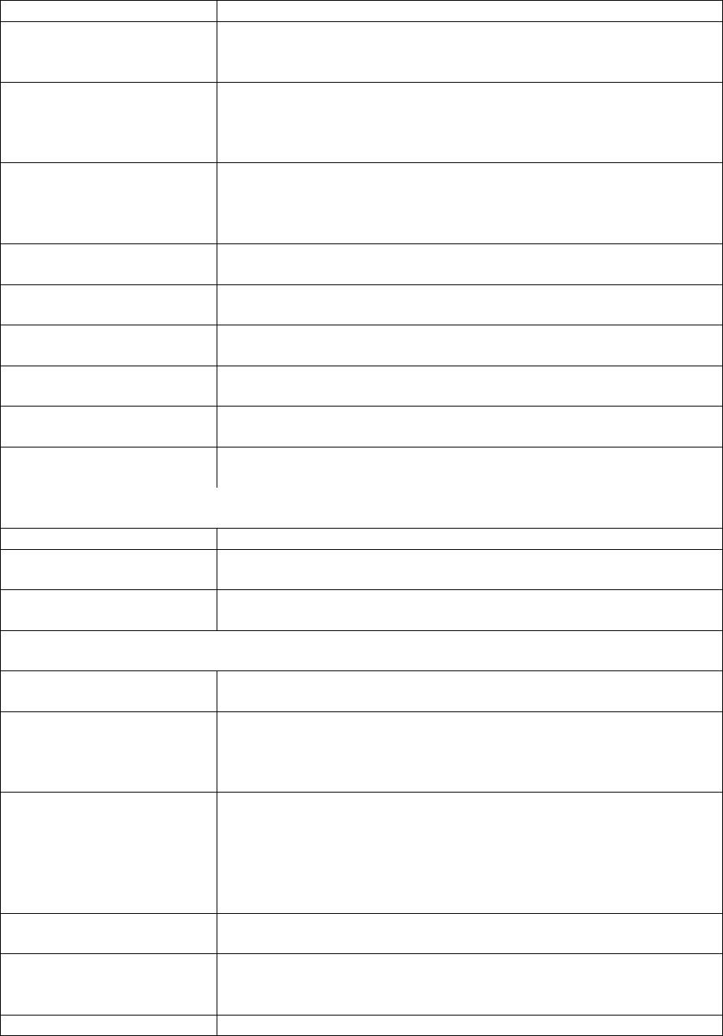

CEO_CHAIR
A dummy variable that equals one if the CEO is also the Chairman of
the Board.
Board Chairman characteristics
CHAIR_AGE
The age of the Chairman.
CHAIR_TENURE
CHAIR_SHARE_OWN
The number of years as Chairman in the current position.
The stock ownership of the Chairman and her related parties acting in
concert.
CHAIR_EDU
CHAIR_EDU is one if the Chairman’s educational level is technical
secondary level or below, two if the educational level is junior college
level, three if the educational level is a bachelor degree, four if the
educational level is a master degree, and five if the educational level
is a doctor degree.
CHAIR_OFFICIAL
CHAIR_PARENT_POS
A dummy variable that equals one if the Chairman of the Board is a
current or former government official at the county or higher level, or
a representative of the People’s Congress or the Chinese People’s
Political Consultative Conference (CPPCC) at the county or higher
level.
CHAIR_PARENT_POS is three if the Board Chairman holds the
position of both the Chairman of the Board and the CEO at the parent
company, two if the Board Chairman holds the position of either the
Chairman of the Board or the CEO but not both at the parent
company, one if the Board Chairman holds any managerial position
lower than the Board Chairman and the CEO at the parent company,
and zero if the Board Chairman holds no managerial position at the
parent company.
CHAIR_MALE
CHAIR_ACCOUNTING
A dummy variable that equals one if the Chairman is male.
A dummy variable that equals one if the Chairman possesses at least
one of the following professional titles: Senior Accountant title
designated by the relevant government agencies, CPA, CFA, CMA, or
has prior working experience in an accounting firm, and zero
otherwise.
CHAIR_COMP
The natural logarithm of the Chairman’s total compensation.
CEO characteristics
CEO_AGE
The age of the CEO.
CEO_TENURE
CEO_SHARE_OWN
The number of years as CEO in the current position.
The stock ownership of the CEO and her related parties acting in
concert.
CEO_EDU
CEO_EDU is one if the CEO’s educational level is technical
secondary level or below, two if the educational level is junior college
level, three if the educational level is a bachelor degree, four if the
educational level is a master degree, and five if the educational level
is a doctor degree.
CEO_OFFICIAL
A dummy variable that equals one if the CEO is a current or former
government official at the county or higher level, or a representative
of the People’s Congress or the Chinese People’s Political
Consultative Conference (CPPCC) at the county or higher level.
CEO_PARENT_POS is three if the CEO holds the position of both the
Chairman of the Board and the CEO at the parent company, two if the
CEO holds the position of either the Chairman of the Board or the
CEO but not both at the parent company, one if the CEO holds any
managerial position lower than the Board Chairman and the CEO at
CEO_PARENT_POS

Electronic copy available at: https://ssrn.com/abstract=3202028


the parent company, and zero if the CEO holds no managerial
position at the parent company.
CEO_MALE
CEO_ACCOUNTING
A dummy variable that equals one if the CEO is male.
A dummy variable that equals one if the CEO possesses at least one
of the following professional titles: Senior Accountant title designated
by the relevant government agencies, CPA, CFA, CMA, or has prior
working experience in an accounting firm, and zero otherwise.
The natural logarithm of the CEO’s total compensation.
CEO_COMP
CFO characteristics
CFO_AGE
The age of the CFO.
CFO_TENURE
CFO_SHARE_OWN
The number of years as CFO in the current position.
The stock ownership of the CFO and her related parties acting in
concert.
CFO_EDU
CFO_EDU is one if the CFO’s educational level is technical
secondary level or below, two if the educational level is junior college
level, three if the educational level is a bachelor degree, four if the
educational level is a master degree, and five if the educational level
is a doctor degree.
CFO_OFFICIAL
A dummy variable that equals one if the CFO is a current or former
government official at the county or higher level, or a representative
of the People’s Congress or the Chinese People’s Political
Consultative Conference (CPPCC) at the county or higher level.
CFO_PARENT_POS is three if the CFO holds the position of both the
Chairman of the Board and the CEO at the parent company, two if the
CFO holds the position of either the Chairman of the Board or the
CEO but not both at the parent company, one if the CFO holds any
managerial position lower than the Board Chairman and the CEO at
the parent company, and zero if the CFO holds no managerial position
at the parent company.
CFO_PARENT_POS
CFO_MALE
CFO_COMP
A dummy variable that equals one if the CFO is male.
The natural logarithm of the CFO’s total compensation.
Notes: Panel A shows the descriptive statistics for the regression variables. Panel B shows the regression
results of the WO model. All variables are measured contemporaneously following Riedl (2004), and
defined in Panel C. All continuous variables are winsorized at the top and bottom one percent. All
regressions include industry×year fixed effects. Heteroskedasticity-consistent standard errors clustered
at the firm level are shown in parentheses below the coefficients. ***, **, and * denote significance at
the 1%, 5%, and 10% levels for two-tailed tests, respectively.
References
Riedl, E. J. 2004. An examination of long-lived asset impairments. The Accounting Review 79 (3), 823–
852.

Electronic copy available at: https://ssrn.com/abstract=3202028
